**Digital safety**

BASIC COMPUTER USAGE



**OBJECTIVES FOR TODAY** 

* Understand about **malware** ✓ Know how to avoid **malware** or **stay safe**
* Know how **importance** of **strong password**

# ✓ Understand what is **phishing**

## Malware/virus



5

MIN

● **What is malware (or virus)?**

* **MAL-icious software (MAL-WARE)** that can **harm** yourself and your computer
* Can **steal** your **data**, **password, credit card information**, **slow down** or even **break** your computer
* Can be **contagious** and **spread** to other computers
* **Spyware** is a kind of malware that can **‘spy’ your activities** on your computer o **Keylogger** is a kind of spyware that **logs** all your **keystrokes** (including passwords, etc.)
* **Ransomware** = **ransom**-ware. Kind of malware that asks you for money (ransom)

## Malware/virus



5

MIN

● **How to stay safe?** o Use an **antivirus** on your computer => It’s the fist step, but not enough!

o Understanding of **attack** by **USB key, web download, email,**

**Messenger/Telegram** o **Stay vigilant:**

* Don’t download file **attachments** from emails unless you trust the sender
* Don’t download **illegal** software (cracks)
* Don’t download any files from **suspicious** websites

## Malware/virus



5

MIN

• **How can it be contagious?**

* Download **free software** from the internet. o Download **Suspicious Email Attachments** o Click on **Phishing** Emails
* Use **External devices**(USB devices, external hard disk.)
* Click on **Online Advertisements** o Visit **Infected** Website o Copying Data From **Infected** Computer o **Social Media Scam Links**

## Password



5

MIN

* **What is a password?**
  + It is a **secret** that you use to prove your identity when accessing your applications o It is a combination of characters that can be alphabetical, numeric or special characters
* **How to stay safe?** o It’s like your **toothbrush** => **never share it** with anyone!! o Don’t use the same password everywhere!
  + Make your password **difficult to guess**

■ No word from dictionary or Name: *apple, elephant, davy, mengheang …*

■ No successive or repetitive characters: *abcd…, 9876…*

■ No date (of birth, wedding, etc), no phone number: *12-09-1999, 01-10-2001, …*

○ Passwords should **complex**

■ Long: at least **8 characters** (or more)

■ Different types of characters: **alphabetical, numeric and special characters**

ACTIVITY

## Password



5

MIN

• **What is wrong with my password?**

o O-f15? o Abcdp91o 7124902367 o mka7F14R o 20Wiwwtp18?

EXPLAN

## Phishing



5

MIN

* **What is phishing?**
  1. Phishing is a way to **fool you** into clicking on a **dangerous link**

○ Phishing is usually sent by **email**, **Messenger**, **Telegram**, **SMS**, etc.

Once you click on the link, you will be connected to **fake website** that looks like the original one

○ The fake website will ask you for your **password** ○ Now the **hackers know your password**!

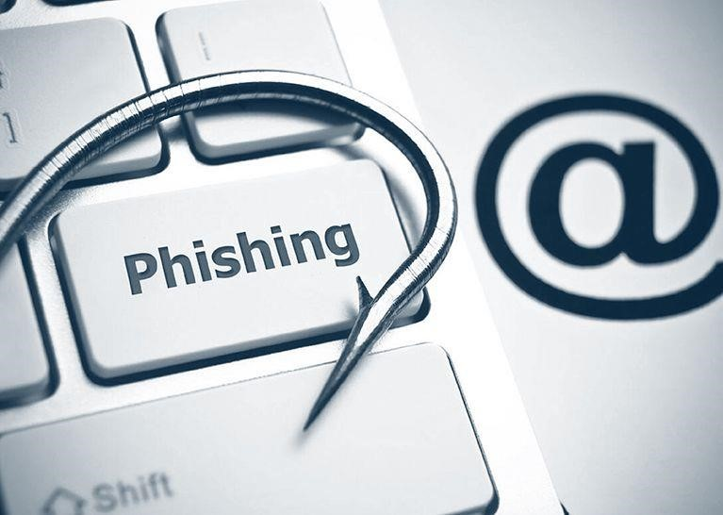

* **How to stay safe?**
  1. **Stay vigilant!**

■ Don’t click on **links** from email,

Messenger, Telegram, SMS, etc. unless you trust the sender

■ Instead, type the URL in your browser